CERTIFIED PUBLIC MANAGER PROGRAM FLORIDA CENTER FOR PUBLIC MANAGEMENT
FLORIDA STATE UNIVERSITY

Level 6 Assignment Guidelines

IMPROVING
SYSTEMS

2023

BACKGROUND

Many practitioners, writers, and scholars believe that government must be transformed from time to time to better serve the public. In this Level 6 Assignment, you are asked to apply systems thinking to address a “big picture” systems problem that impacts your agency.

Traditionally, most improvement efforts focus on the work process level (such as the CPM Level 2 Assignment), but in this Assignment we want you to focus on a higher level: the system, sub-system, or work system level. These may cross over traditional organizational boundaries to include other divisions, agencies, or customer groups.

Peter Senge proposes that one reason improvement strategies fail is that they focus too narrowly on “detail complexity” instead of seeing the interdependencies and relationships that affect the overall system—what he calls “dynamic complexity.” This assignment asks you to shift your thinking from the detail complexity of your individual work processes to the dynamic complexity of systems and the relationships between multiple elements in those systems.

The following illustrates the relationships between these terms:

SYSTEM

↕

SUB SYSTEM

↕

WORK SYSTEM

↕

WORK PROCESS

↕

INDIVIDUAL PERFORMANCE

The delineation between these five layers can be elusive and can sometimes be applied differently depending on what is being viewed and by whom. When you focus at the work process level, you can identify various work processes easily. As you move up to higher levels, however, there are multiple relationships that come into play. In addition, there could be more layers depending on the complexity of the role the organization is playing within the larger system.

We have included a diagram that illustrates these levels in one type of organization.

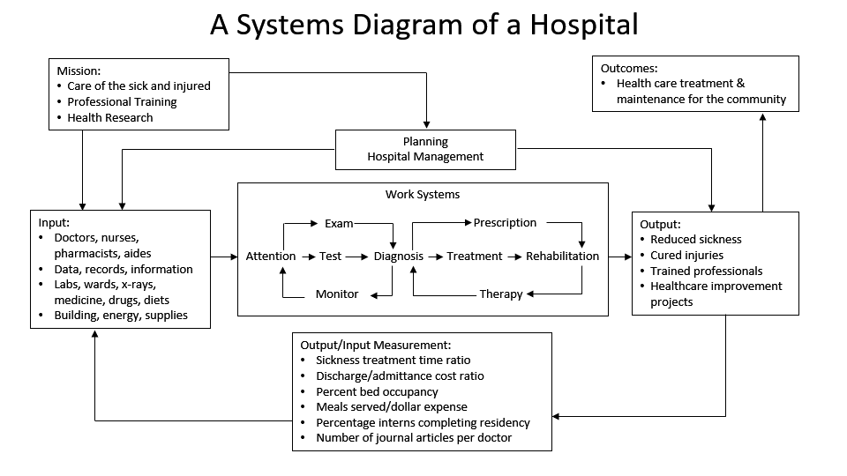
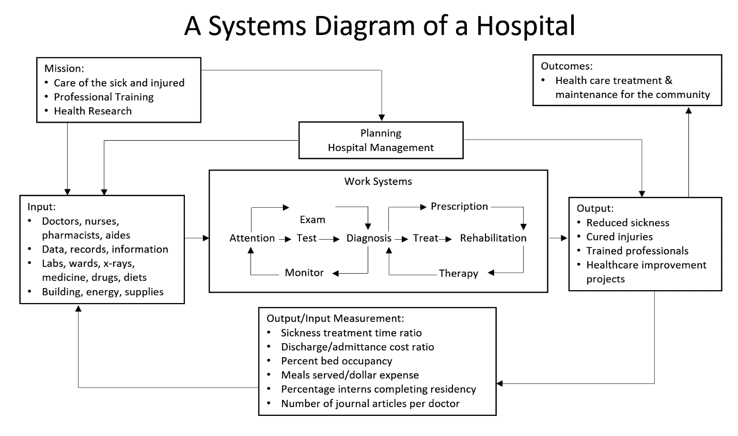

SYSTEM

Healthcare
↕
SUB-SYSTEM

Hospital (one of many)

↕

WORK SYSTEM:

Treatment (one of many)

↕

SUB-WORK SYSTEM:

Surgery (one of many)

↕

WORK PROCESS:

Anesthesia (one of many)

↕

INDIVIDUAL PERFORMANCE

Anesthesiologist (one of many)

Procedures

- Create a title page showing your name, email address, phone number, and date.

  - Cut and paste the questions, then type your answers to each question.

3. Upon completion, you should submit this assignment through website:

FCPM Student Login (fsu.edu)

This will bring up a log-on screen. Enter your email address and password (the last four digits of your Social Security number), then click “Next Step.”. This will take you to your Transcript.

Click on “Submit Assignment” for the particular assignment or exam. If you are uploading a Group Assignment, enter the names and email addresses of group members in the drop-down menu. Click “Browse” and locate the file on your hard drive (usually in “My Documents”), then click “Open.” Once the file is listed in the menu, click “Submit File.”

Your submission will be automatically entered into the database. It will show on your transcript as “Submitted.” You will also receive an automated email notifying you that it has been added to your transcript.

Once your assignment is graded, and if it passed, you will receive an automated email saying that it has been “Completed.” If your submission does not pass, you will receive an email telling you to resubmit, and explaining what you need to do to pass. Your work will be graded within 60 days, although CPM instructors typically grade assignments sooner than that.

If you encounter problems submitting your homework, please contact Dan Vicker, the CPM Student Liaison, at dvicker@admin.fsu.edu or the CPM office at CPM@admin.fsu.edu . You can phone our main number at 850-644-6460 or 850-644-0161.

Submissions will not be returned, so you should keep a copy for future reference. Your work is considered confidential, and the CPM Program will not share or discuss it with anyone, other than you.

OVERVIEW

This assignment requires you to apply the concepts of systems thinking, as discussed in Level 6, to a “big picture” systems problem that impacts the outcomes of your agency. You are expected to draw upon and reference materials from the notebook or from outside reading on systems. Your submission must include the following steps:

STEP ONE

- Identify a “big picture” systems problem that impacts your agency.

- Give a detailed description of this problem and how it diminishes the results of the system and your agency’s ability to achieve its desired outcomes within that system.

STEP TWO

- Describe the larger system(s) in which this problem exists.

- Describe the purpose of this system in terms of its desired results.

STEP THREE

- Drawing on Level 6, Module 4 (Systems Modeling), create a systems diagram (model) of this system and how your organization fits into that system or diagram the causal loops leading to the problem.

- Be sure to show the various elements in this system and the connections between them.

STEP FOUR

- Provide a narrative description of the relationships between the elements of this system and any patterns of influence among them.

- Be sure to describe the interdependencies that exist among these elements (describe any reciprocal influences or feedback loops among the elements).

STEP FIVE

- Systems thinking attempts to understand why complex problems exist. In your example, provide an in-depth description of why you believe this problem exists. You should provide background information about how this problem arose and any previous attempts that failed to fix it. You may find it useful to reference some of the basic systems principles covered in Level 6, Module 1.
- Apply the Seven S model to your agency, describe some of the high-level changes you would recommend. You may find the materials in Level 6, Module 3 helpful to you.
- Based on your findings of the Reinventing Government Blockage Survey, what organizational adjustments would need to be made to ensure your recommendations become successful? Level 6, Module 2 may be helpful to you.

STEP SIX

- Russell Ackoff suggests that there are four ways to treat a problem: absolve (wash your hands), resolve (quick fix), solve (satisficing), and dissolve (changing the system). Systems thinking attempts to redesign the system so the problem is dissolved. As a systems thinker, how would you dissolve this problem? What changes would need to be made in the elements of the system? Provide a detailed recommendation for your recommendation.

- If your proposed changes were to be implemented, what outcomes would you envision?

